ECA 1011 – MICROPROCESSOR AND MICROCONTROLLERS
Name : kuberachari.s
Reg No : 1912260272
Exp 01: Analysis Development and Verification of 8 bit and 16 bit Arithmetic Operations using Assembly Language
Objectives:
- To Analysis and Verify 8 bit Addition and Subtraction using 8 bit Micro Processor
- To Analysis and Verify 16 bit Addition and Subtraction using 8 bit Micro Processor
- To Analysis and Verify 8 bit Multiplication and Division using 8 bit Micro Processor
- To Analysis and Verify 16 bit Multiplication and Division using 8 bit Micro Processor
Components Required:
8085 Simulator
Procedure:
- Launch your 8085 Simulator application on your system.
- Type or paste the Assembly Language Program (ALP) into the editor/assembler window.
- Click on the Assemble or Compile button to convert the assembly mnemonics into machine code. Ensure there are no syntax errors.
- Open the Memory Editor window and manually enter your input hex operands into the designated starting memory addresses.
- Click Run or use Step-by-Step execution to trace the accumulation and flag changes.
- Check the specified target memory locations and register statuses to verify your mathematical outputs.

- To Analysis and Verify 8 bit Addition and Subtraction using 8 bit Micro Processor
Code:
Addition:
LDA 4000
MOV B A
LDA 4001
MVI C 00
ADD B
JNC SKIP
INR C
SKIP:
STA 4002
MOV A C
STA 4003
HLT
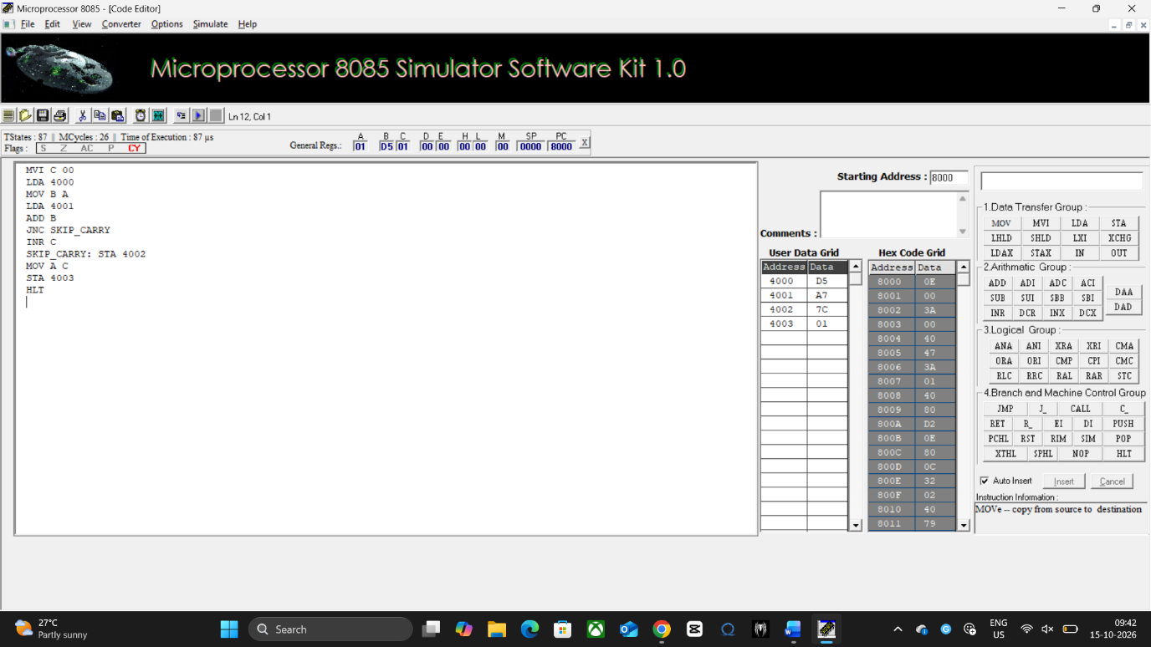
Data Table:
4000 | D5
4001 | A7
4002 | 7C
4003 | 01
Subtraction:
LDA 4000
MOV B A
LDA 4001
MVI C 00
SUB B
JNC SKIP
INR C
CMA
ADI 01
SKIP: STA 4002
MOV A C
STA 4003
HLT
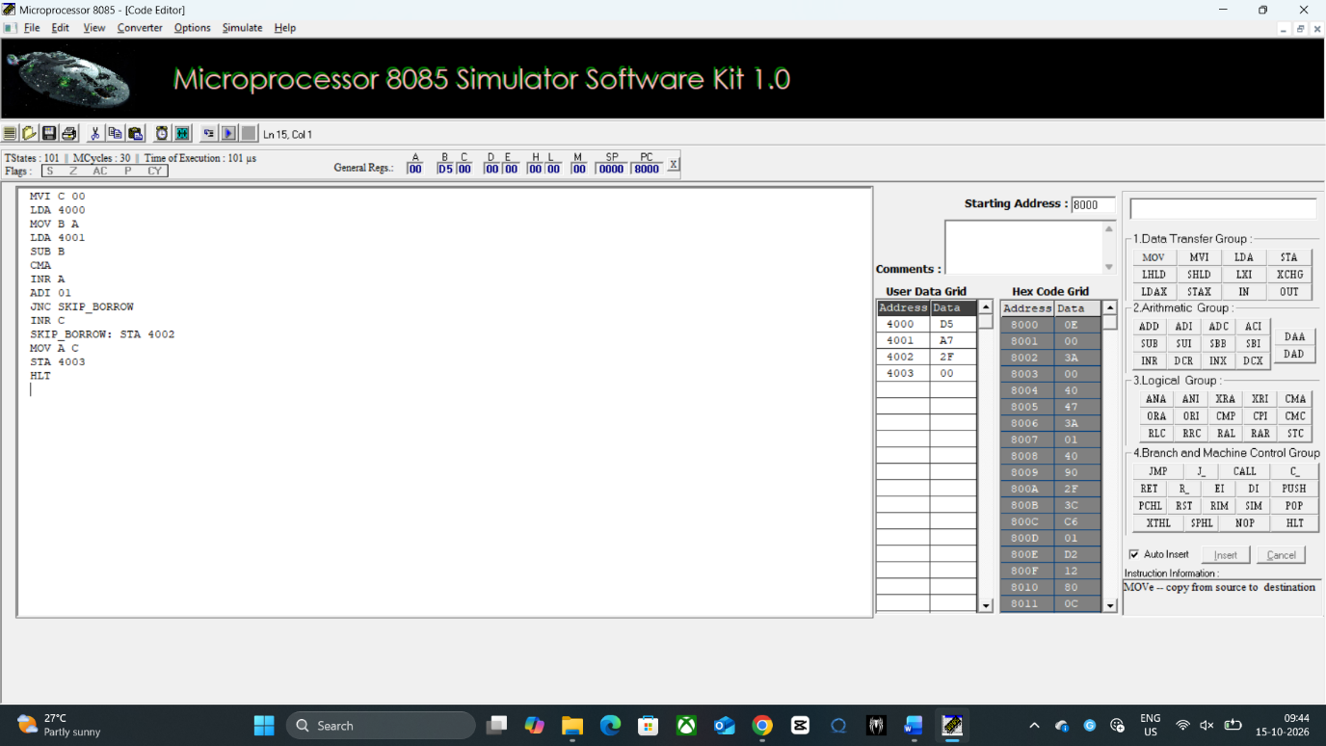

Data Table:
4000 | D5
4001 | A7
4002 | 7C
4003 | 01
- To Analysis and Verify 16 bit Addition and Subtraction using 8 bit Micro Processor
Code:
Addition:
MVI C 00
LHLD 4000
XCHG
LHLD 4002
DAD D
JNC SKIP_CARRY
INR C
SKIP_CARRY: SHLD 4004
MOV A C
STA 4006
HLT
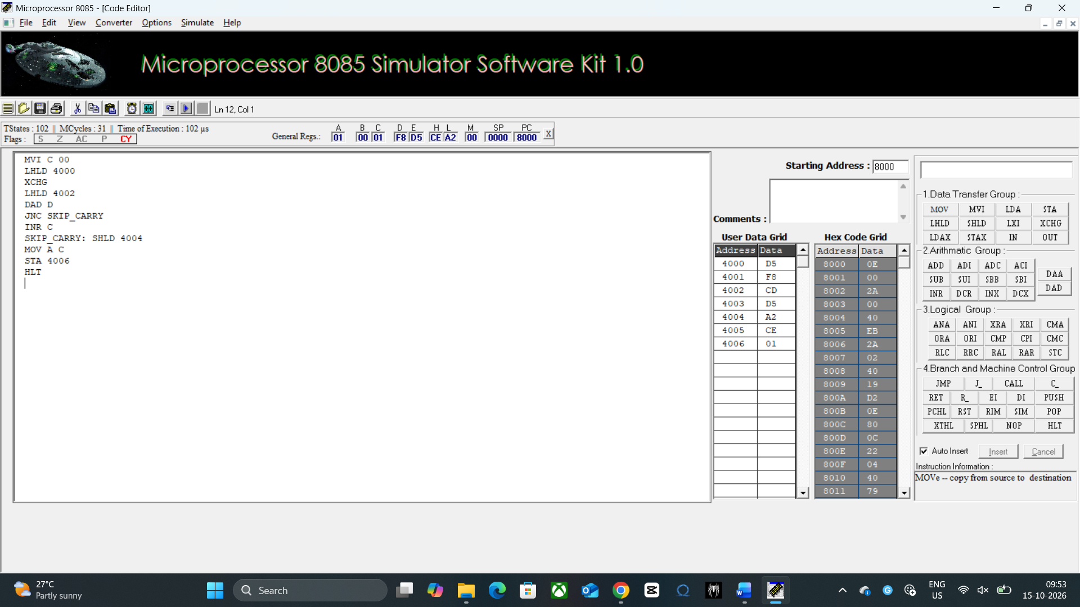
Data Table:
4000 | D5
4001 | F8
4002 | CD
4003 | D5
4004 | A2
4005 | CD
4006 | 01
Subtraction:
MVI C 00
LHLD 4000
MOV A L
LHLD 4002
SUB L
MOV L A
MOV A H
SBB H
MOV H A
JNC SKIP_BORROW
INR C
CMA
MOV H A
MOV A L
CMA
ADI 01
MOV L A
MOV A H
ACI 00
MOV H A
SKIP_BORROW: SHLD 4004
MOV A C
STA 4006
HLT
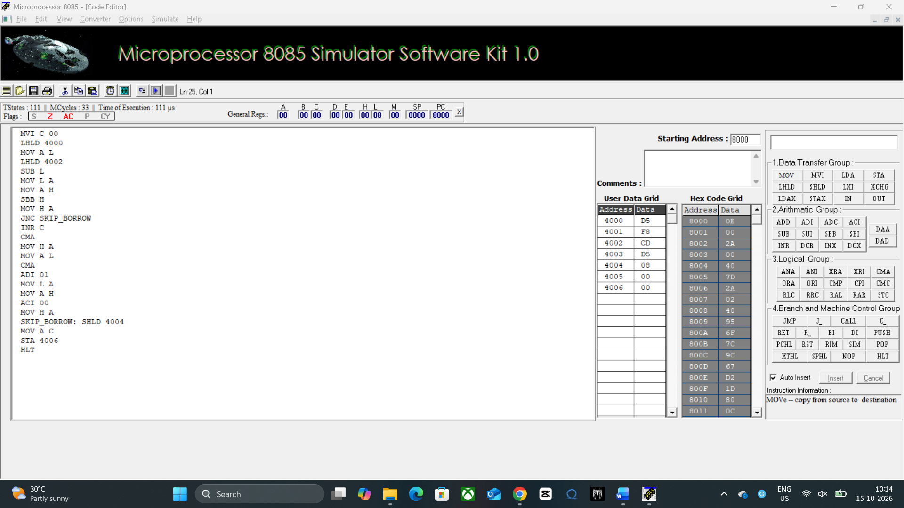

Data Table:
4000 | D5
4001 | F8
4002 | CD
4003 | D5
4004 | 08
4005 | 23
4006 | 00

- To Analysis and Verify 8 bit Multiplication and Division using 8 bit Micro Processor
Code:
Multiplication:
MVI C 00
LDA 4000
MOV B A
LDA 4001
MOV D A
MVI A 00
LOOP: ADD B
JNC SKIP_CARRY
INR C
SKIP_CARRY: DCR D
JNZ LOOP
STA 4002
MOV A C
STA 4003
HLT
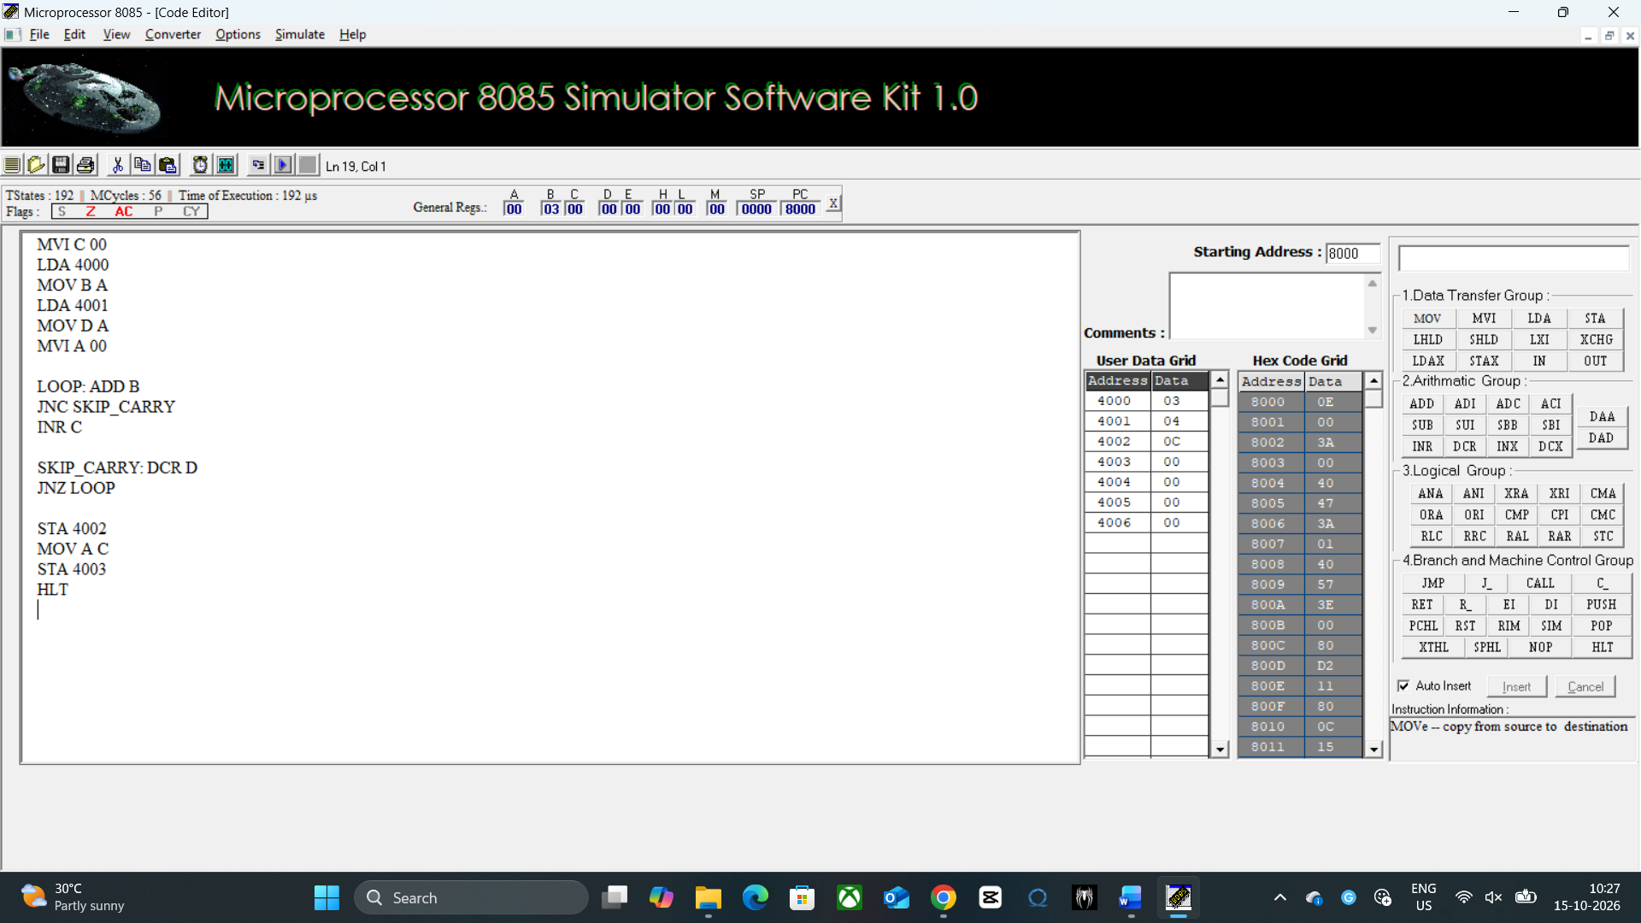
Data Table:
4000 | 03
4001 | 04
4002 | 0C
4003 | 00

Division:
MVI C 00
LDA 4000
LDA 4001
MOV B A
LDA 4000
LOOP: CMP B
JC STORE
SUB B
INR C
JMP LOOP
STORE: STA 4003
MOV A C
STA 4002
HLT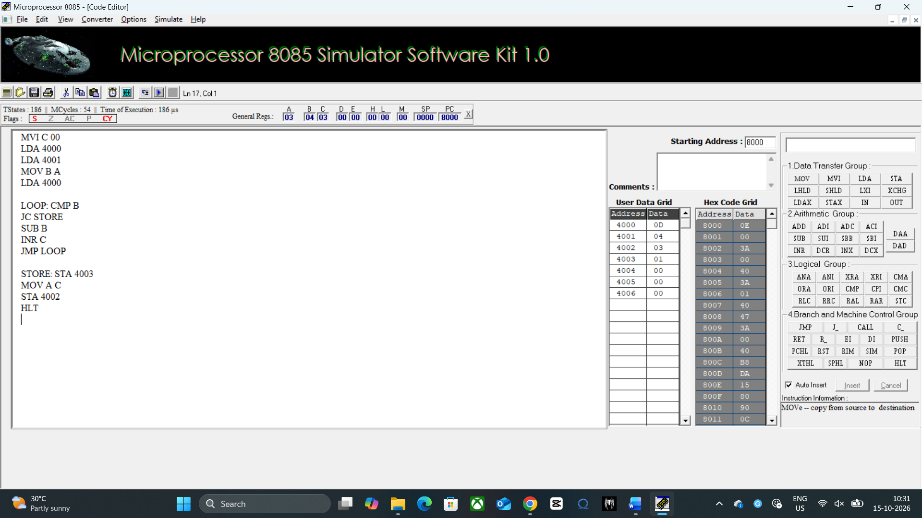
Data Table:
4000 | 0D
4001 | 04
4002 | 03
4003 | 01

- To Analysis and Verify 16 bit Multiplication and Division using 8 bit Micro Processor
Code:
Multiplication:
LHLD 4000
XCHG
LHLD 4002
MOV C L
MOV B H
LXI H 0000
LOOP: MOV A C
ORA B
JZ STORE
DAD D
DCX B
JMP LOOP
STORE: SHLD 4004
HLT
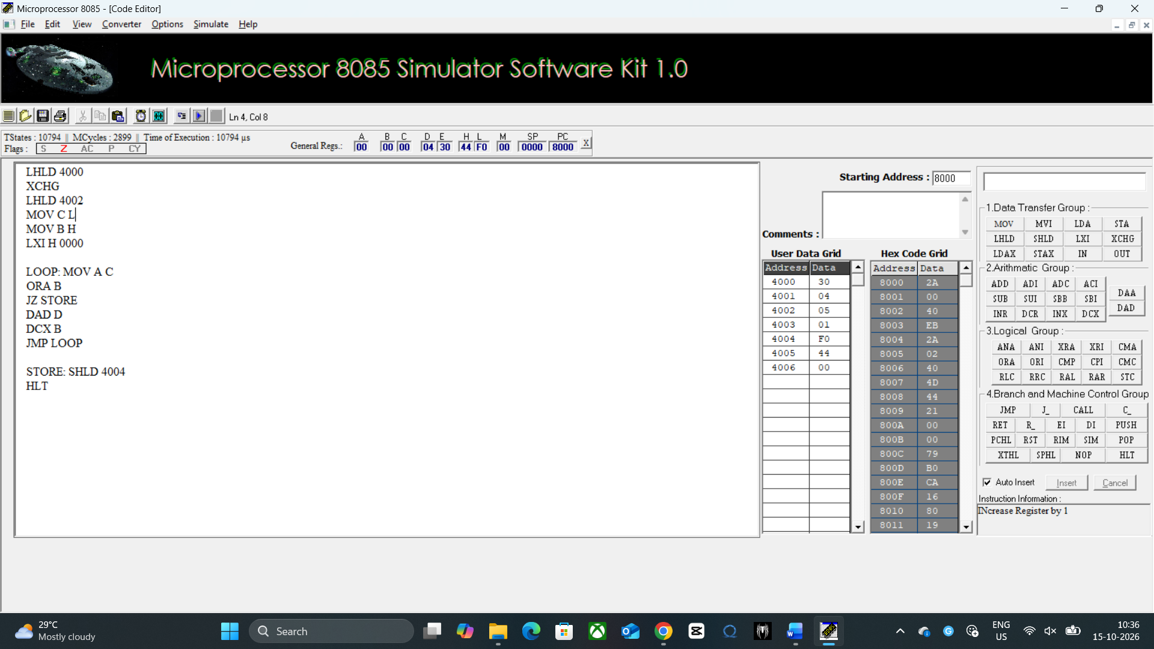
Data Table:
4000 | 03
4001 | 04
4002 | 05
4003 | 01
4004 | F0
4005 | 44
4006 | 00

Division:
LXI B 0000
LHLD 4000
XCHG
LHLD 4002
LOOP: MOV A E
SUB L
MOV A D
SBB H
JC STORE
MOV A E
SUB L
MOV E A
MOV A D
SBB H
MOV D A
INX B
JMP LOOP
STORE: XCHG
SHLD 4006
MOV L C
MOV H B
SHLD 4004
HLT
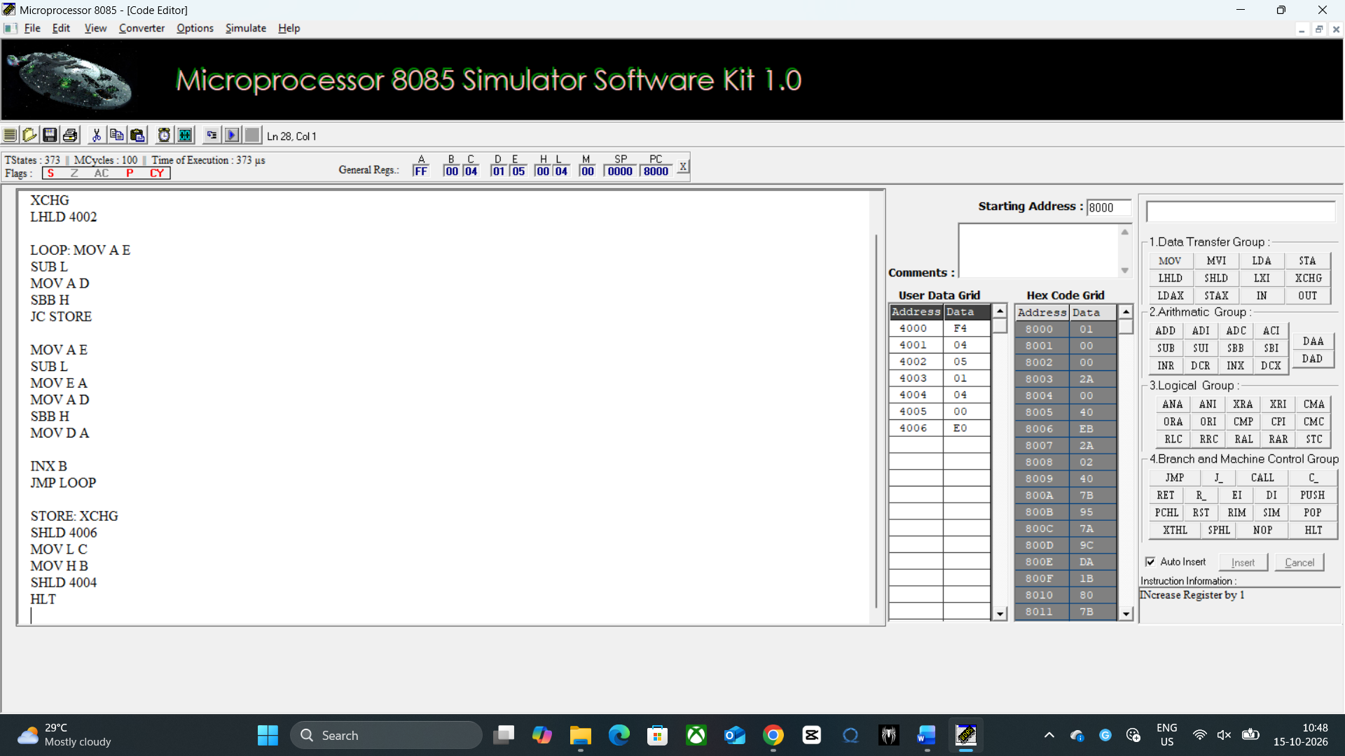
Data Table:
4000 | F4
4001 | 3D
4002 | 05
4003 | 01
4004 | 3C
4005 | 00
4006 | C8

Result:
- 8-bit Addition and Subtraction: The target memory location holds the correct 8-bit sum or difference, and the adjacent byte records 01H if an overflow carry or borrow occurred, or 00H if it did not.
- 16-bit Addition and Subtraction: The sequential memory addresses store the low and high bytes of the correct 16-bit sum or difference, along with a final byte reflecting the state of the terminal carry or borrow flag.
- 8-bit Multiplication and Division: The output registers or memory addresses contain either a combined 16-bit product from repeated addition, or two distinct 8-bit bytes representing the exact Quotient and Remainder from repeated subtraction.
- 16-bit Multiplication and Division: The designated target memory blocks accurately hold a multi-byte product (up to 32 bits) generated by the double-addition loop, or a pair of 16-bit values containing the final Quotient and Remainder.

